Splunk SIEM Security Monitoring Lab
Project Screenshots and Documentation

Figure 1: Windows Failed-Login Investigation
Description: Imported Windows Security Event ID 4625 logs into Splunk Cloud and investigated eight failed-login events. Identified seven time synchronization errors and one authentication failure.
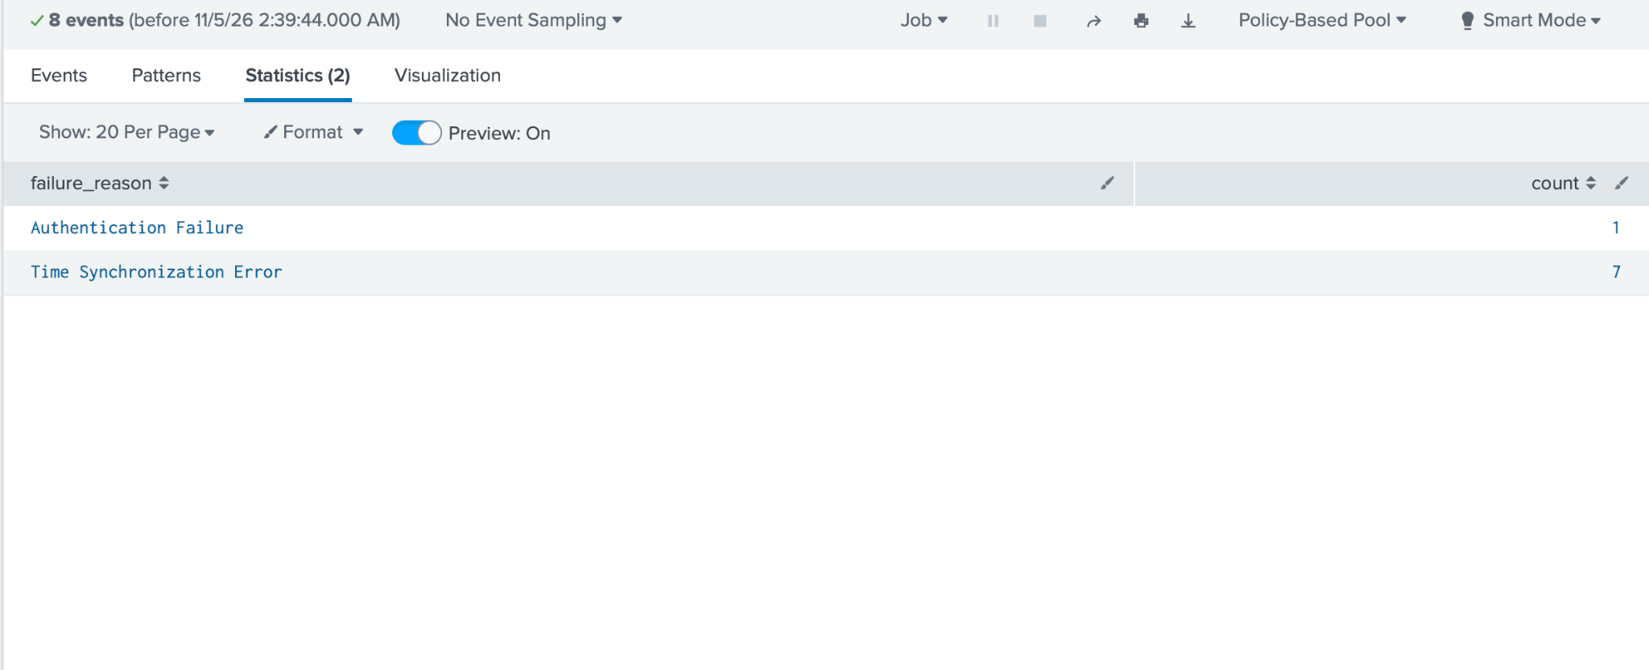

Figure 2: Windows Security Monitoring Dashboard
Description: Created a Splunk dashboard displaying failed-login activity over time and authentication failure reasons using column and pie charts.
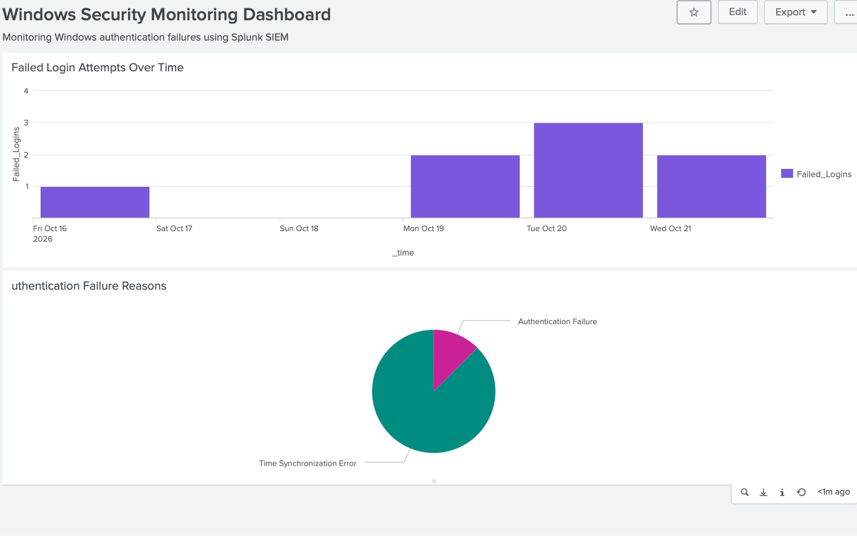

Figure 3: Windows Failed-Login Detection Alert
Description: Configured a scheduled Splunk alert to detect five or more failed-login events within 15 minutes. The alert is enabled but has not yet been tested with live log forwarding.


